Vocabulary: The House
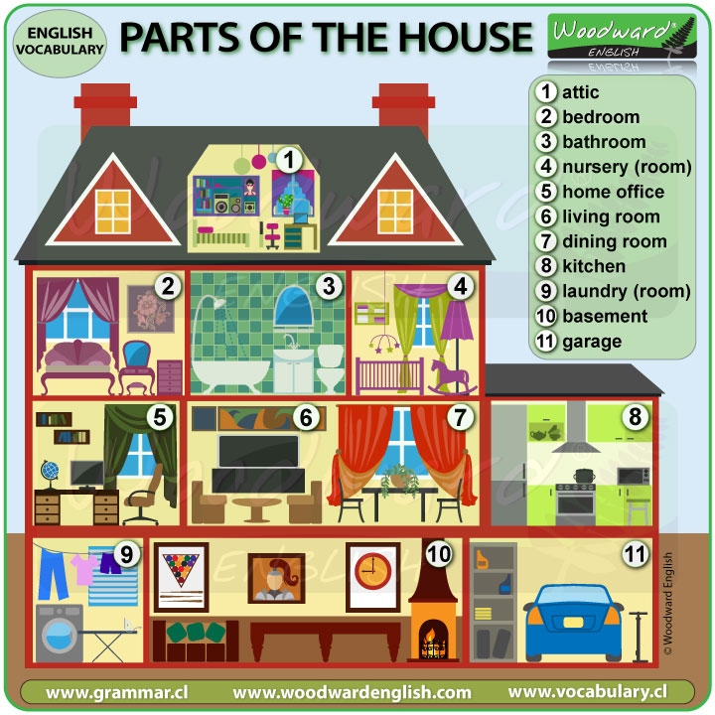

There is/ There are

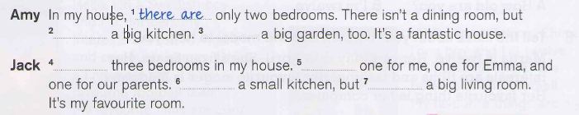
Activity: https://es.liveworksheets.com/worksheets/en/English_as_a_Second_Language_(ESL)/There_is_-_there_are/House_furniture_mq1245469og
Question Words
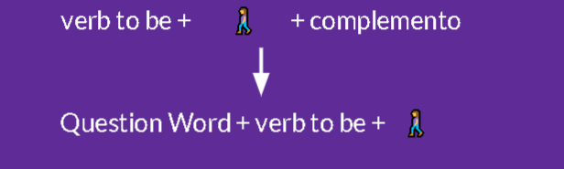
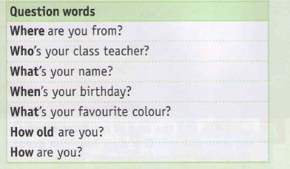
Activity: https://es.liveworksheets.com/worksheets/en/English_as_a_Second_Language_(ESL)/Question_words/Question_words_fc139qx

Bedroom Vocabulary
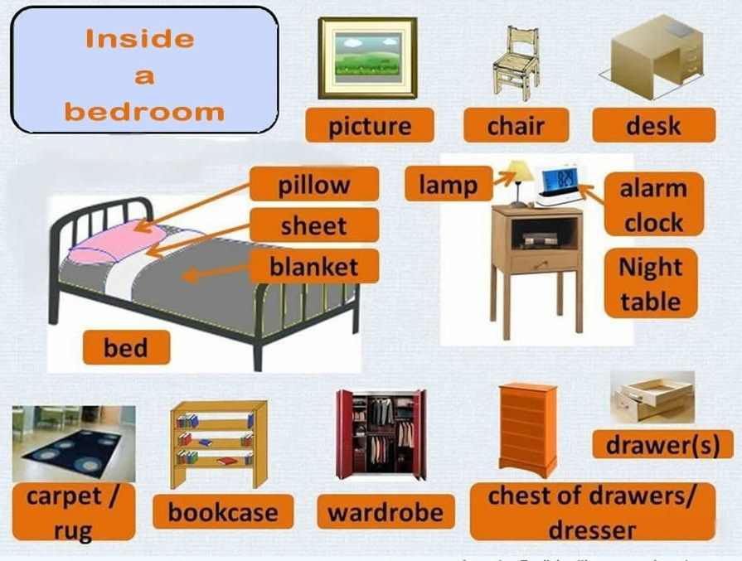
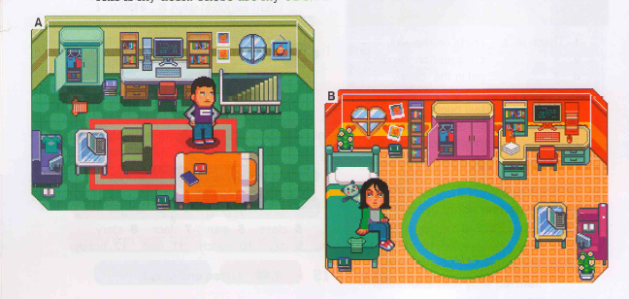
This, That, These, Those
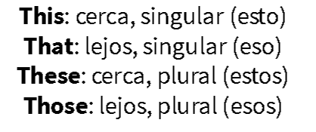
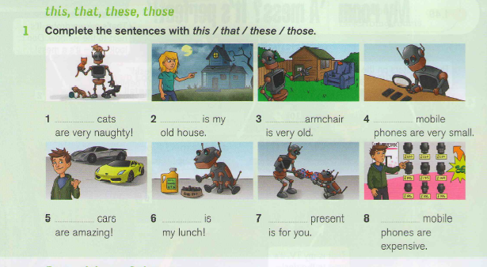
Prepositions of Place
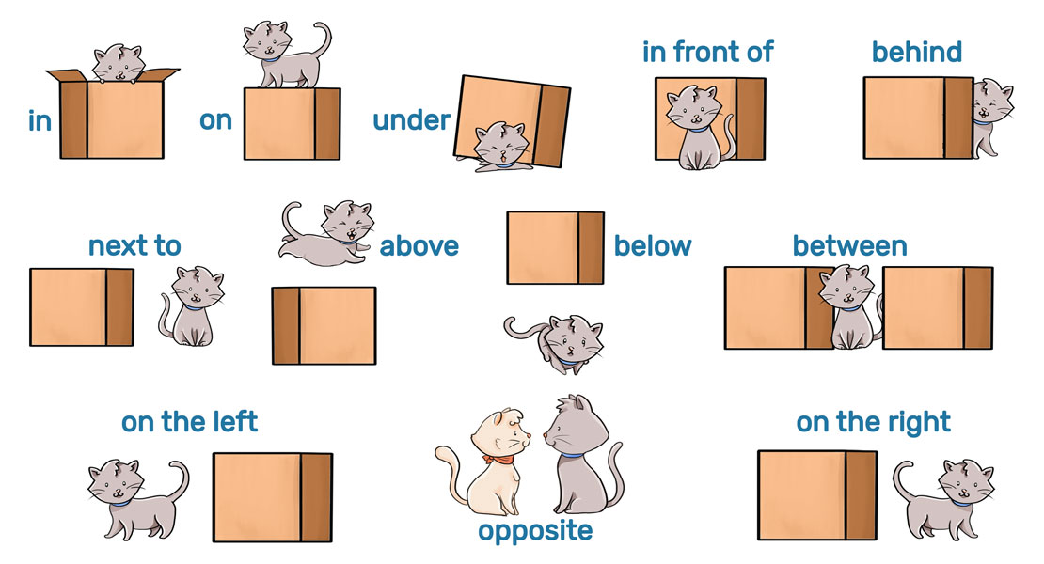
Activity: https://es.liveworksheets.com/worksheets/en/English_as_a_Second_Language_(ESL)/Prepositions_of_place/Prepositions_of_place-1ESO_no1470835uj

